**Empowering Students through Android Applications**

Authors: Melissa Serrano, Alain Edwards, Sifat Islam, Ravi Shankar, Iris Minor, Susanne Lapp

**Abstract**

During the fall 2014 semester at FAU a group of undergraduate students created an app to empower middle school students called Cityville, which had the highest ranking among judges at the end of the semester. The pilot version of the Cityville app allows users to add community events and report locations of concern in their community. I propose to enhance the pilot version of Cityville by allowing users to personalize the app through a customizable UI, integrate the app with their preferred social media account, and implement web crawling and social media mining techniques to lay the groundwork for some events and reports in the database. I have included mockups of my proposed changes. I feel that the enhancements I have proposed are extremely important to obtain the amount of usage we are wanting out of the students with the app. Without a significant amount of usage it would make Sifat’s research data very sparse and likely inaccurate. Upon implementation of my proposed enhancements we will have achieved an Android app which will empower middle school students as well as provide Sifat with useful data which he can use in his analysis.

**Background**

The expansion of internet use on mobile devices and the vast accessibility to technology since the turn of the millennium has greatly empowered our society. Twenty years ago a child might have asked his dad how to fix the chain on his bicycle when it fell off, now that same child won’t wait for dad to get home from work– he’ll look it up on YouTube! Having an endless sea of knowledge at our fingertips is a great empowerment tool. But does everyone realize how empowering the internet and technology is?

Bill Gates once stated, “As we look ahead into the next century, leaders will be those who empower others.” During the fall 2014 semester at FAU, Professor Shankar’s undergraduate Android Application Development class showed that all of us are leaders, because every one of us has the ability to empower others in some way. With suggested topics from community youth counselor Iris Minor, the students developed many Android applications designed to empower students. <https://github.com/RShankar/Empower-App-Cityville-Fall-2014> Among the apps created the Cityville App was ranked the highest by a group of academic, high tech, and movie industry professionals at FAU, and therefore chosen to be used in a study to analyze STEM interest amongst middle school students. With my contributions, the Cityville App will empower middle school students by allowing them to add community events or safety reports to Cityville that were not already collected, customize the UI, and integrate Cityville with their preferred social media app. The usage of Cityville by the middle schoolers will then be analyzed by PhD candidate Sifat Islam to study the students’ usage as it pertains to STEM interest and activities.

**Pilot method**

Among the Android apps developed by Professor Shankar’s undergraduate class was ‘Cityville’ created by Alain Edwards, Adam Moulton, and Lance Williams. Cityville’s pilot method features a dynamically loading grid view, interactive Google Maps view, reporting of neighborhood safety information, a form to allow users to post a city event, and a form that allows users to report safety advisories. The Java programming language was used to develop the core functionality of the Android application and it is extended by the use of the Parse.com and Google Play Services plugins. Two Google Play Services APIs were used: Google Maps API and Google Analytics API. Google Maps API is used to allow for an interactive map view. The interactive map view allows users to see locations of events and safety alerts such as locations of police, fires, and traffic posted within the Cityville app. Google Analytics API is used for reporting and tracking the usage of the Cityville app. Some of the data the pilot version of the app currently tracks are the number of times a particular view is loaded, the number of events posted within a specified time period, number of safety reports posted within a specified time period, what type of devices are being used to access the application, among other metrics. The Parse.com plugin is used so that all the event and safety advisory data can be stored in the Parse database.

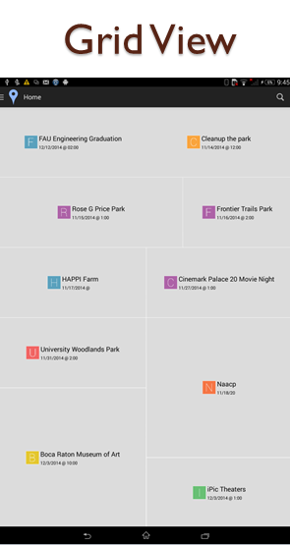 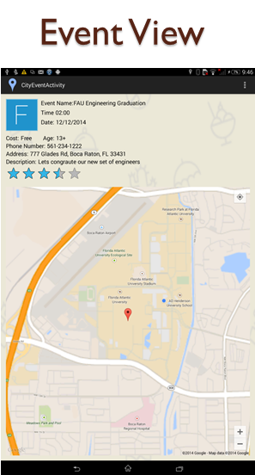 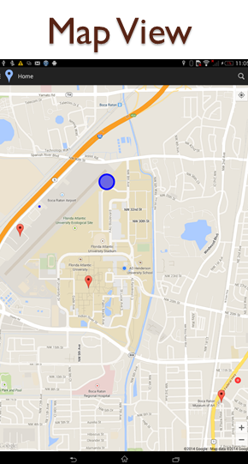

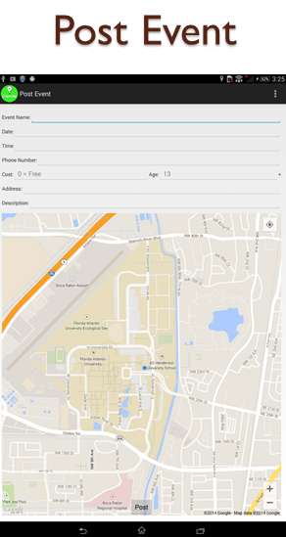 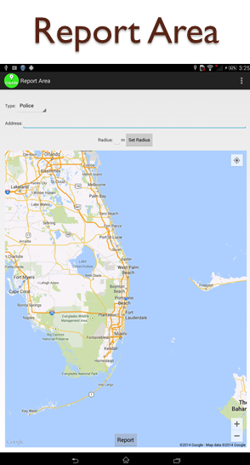

**Proposed Enhancements**

To enhance the pilot version of Cityville developed by the undergraduate students I propose to allow users to personalize the app through a customizable UI, integrate the app with their preferred social media account, and implement web crawling and social media mining techniques to lay the groundwork for some events and reports in the database.

In addition to allowing users to post events and safety advisories, I propose to use web crawling and social media mining techniques to collect information for events and reports. Use a preferential web crawler which will look for “event” topics to find events relevant to a specific area. Many community organizations and local governments post their planned events on their Facebook pages, some sheriff and police departments even post known road blocks on Facebook. Use Facebook API to obtain information from these pages. For other types of reports such as traffic, and crime/police locations I will use either of these methods which seem to be more effective in retrieving that particular data set. The information collected will be stored in the Parse.com database. Since we know that for our purposes this app will be used by students in Broward County, Florida we can keep the events and reports obtained from the web mining limited to activities within Central and South Florida. However for the app to later become more widely used, time permitting I will develop an algorithm to retrieve and store events and advisories related to the users location and clear unrelated activities out of the database in order avoid bloating the database with unnecessary data.

I also will make the UI customizable by adding a “Personalize” button to the slide out menu allowing users to: choose a color scheme, upload an avatar, and create a unique handle associated with their account.

Most importantly, I will enhance the app to allow students to integrate the Cityville app with their preferred social media account. By doing this the students will continue using the social apps they always use and more readily upload events they are chatting about in their social networks to Cityville. With this feature I will provide Sifat with the means to analyze users’ connections in their social networks and relevant conversations they are having by recording the event that the student accessed this social network and allowing access to it. More research must be done here for the specific social media apps we choose to use, while some have APIs which allow for easy access to this information I am not sure that all which are used by middle school aged students have these capabilities. As a preliminary survey, Erika Serrano, 8th grader at Osceola Middle School, polled middle schoolers usage of social media sites: Her findings are that amongst middle schoolers Tumblr is used a lot, by those that have it – however almost everyone has Facebook.

Erika ranked the top 5 social media sites by popularity and most used amongst her middle school peers:

1. Facebook
2. Instagram
3. Snapchat
4. Tumblr
5. KIK

Iris will give a pre-survey to the students who will be using the app soon while I am still in the development process so that I can ensure I include the most widely used social media apps by these students. This is so that we can obtain maximum usage, data, and results.

I will also include code to ensure we can track the information which Sifat wants to analyze and monitor, through Google Analytics or other means that may be necessary in order to measure how empowered the kids are by tracking connections made within their integrated social media account, events and reports uploaded, as well as the extent of their personalization of the app. <https://github.com/meMelster/Empower-App-Cityville-Fall-2014>

**Results**

/*Comment about the end result of completed development*/

**Discussion**

In order to give the app more “value” I feel it is important not to rely solely on user input of events and safety advisories, doing this may result in the app having a sparse amount of data. With my proposed enhancement of mining the web and social media for relevant events and reports it will give the students incentive to use the app, even initially. To give the app a more personalized and social feel I will make the UI customizable by adding a “Personalize” button, this will make the app more fun for this age group. I am adding this aspect because it will allow the students to show empowerment and individuality by self-expression, while providing another metric to measure student empowerment. In order to increase usage of the app I think that it is extremely important to allow students to integrate the Cityville app with their preferred social media account. If this app is just another app they download they’ll probably take a look at it a few times and go back to their usual social apps whether it’s Facebook, Instagram, Snapchat, Tumblr, KIK, or any others. By giving the students this option, the app will work more closely with what they are already doing. This also allows for us to collect more data connected to each student for Sifat to analyze.

**Conclusion**

Upon implementation of my proposed enhancements we will have achieved an Android app which will empower middle school students as well as provide Sifat with useful data which he can use in his analysis by making the app easy to integrate with what the students are already doing and giving it the personalized feel they are accustomed to with many other social games and apps.

**References**

<https://github.com/RShankar/Empower-App-Cityville-Fall-2014/wiki>

Liu, B. 2011 *Web Data Mining* Heidelberg: Springer

/*Once research on APIs going to use for social web mining include those links here*/